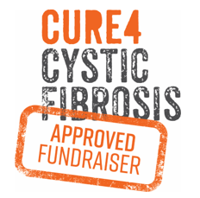

MINI

STARTING IN RYLSTONE @ 10.30 AM
SATURDAY JULY 25, 2020 TO SUNDAY JULY 26, 2020
2020 ENTRY FORM


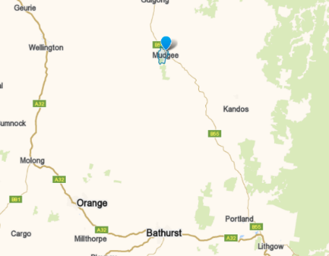




Car Name: |  | Car No.
Principal Entrant:
Address: |  | PC:
Mobile: |  | PH:
Email:

TEAM MEMBER’S NAME: | EMAIL: | MOBILE:
Please return the COMPLETED FORM BY MONDAY JULY 20 to:
Terry Stewart Mobile: 0413 704 104
Email: Trackboss508@gmail.com (AKA “Track Boss”)
Cure4 Cystic Fibrosis: https://cure4cf.org/

