

MINI

STARTING Beatty Hotel Gresford East @ 8 AM
SAT OCTOBER 24, TO SUNDAY OCTOBER 25, 2020
‘TO THE BUSH FOR THE BUSH’

2020 ENTRY FORM

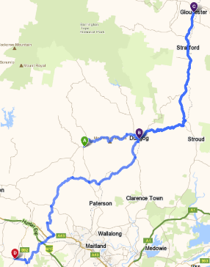




Car Name: |  |  | Car No.
Principal Entrant:
Address: |  |  | PC:
Mobile: |  |  | PH:
Email:

TEAM MEMBER’S NAME: | EMAIL: | MOBILE:
Please return the COMPLETED FORM BY MONDAY OCTOBER 19 to:
Terry Stewart Mobile: 0413 704 104
Email: Trackboss508@gmail.com (AKA “Track Boss”)
Cure4 Cystic Fibrosis: https://cure4cf.org/

